PIZZA SALES SQL QUERIES

A. Key Performance Indicators

1. Total Revenue:

SELECT SUM(total_price) AS Total_Revenue FROM pizza_sales;

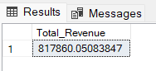

2. Average Order Value

SELECT SUM(total_price) / COUNT(distinct order_id) as Average_OrderVal ;

from pizza_sales;

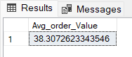

3. Total Pizzas Sold

SELECT SUM(quantity) AS Total_pizza_sold FROM pizza_sales;

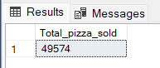

4. Total Orders

SELECT COUNT(DISTINCT order_id) AS Total_Orders FROM pizza_sales;

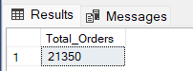

5. Average Pizzas Per Order

SELECT CAST(CAST(SUM(quantity) AS DECIMAL(10,2)) / CAST(COUNT(DISTINCT order_id)

AS DECIMAL(10,2)) AS DECIMAL(10,2)) AS Avg_PizzaOrder FROM pizza_sales;

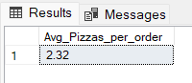

B. Hourly Trend for Total Pizzas Sold

SELECT DATEPART(HOUR, order_time) as order_hour, SUM(quantity) as Total_pizzas_Sold

from pizza_sales

group by DATEPART(HOUR, order_time)

order by order_hour asc;

Output

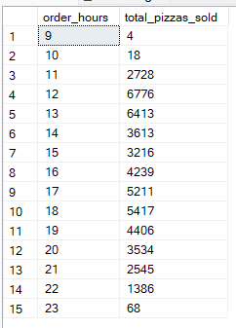

C. Weekly Trend for Orders

SELECT

DATEPART(YEAR, order_date) AS Year,

DATEPART(WEEK, order_date) AS Week,

COUNT(DISTINCT order_id) AS OrderCount

FROM

pizza_sales

GROUP BY

DATEPART(YEAR, order_date),

DATEPART(WEEK, order_date)

ORDER BY

Week;

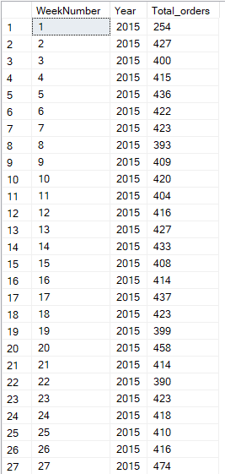 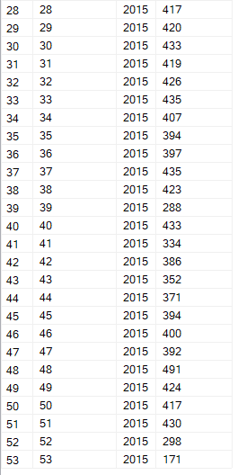

D. % of Sales by Pizza Category

SELECT

pizza_category, ROUND(SUM(total_price),2) AS Total_sales,

ROUND(SUM(total_price) * 100.0 /

(SELECT SUM(total_price) FROM pizza_sales), 2)

AS Percent_Total_sales

FROM pizza_sales

-- WHERE MONTH(order_date) = 1

GROUP BY pizza_category;

Output

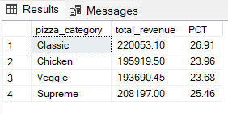

E. % of Sales by Pizza Size

SELECT

pizza_size, ROUND(SUM(total_price),2) AS Total_sales,

ROUND(SUM(total_price) * 100.0 /

(SELECT SUM(total_price) FROM pizza_sales), 2)

AS Percent_Total_sales

FROM pizza_sales

-- where DATEPART(Quarter, order_date) = 1 -- for quarters

GROUP BY pizza_size

order by Percent_Total_sales desc;

Output

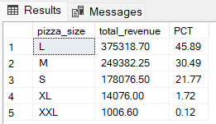

F. Total Pizzas Sold by Pizza Category

SELECT pizza_category, SUM(quantity) as Total_Quantity_Sold

FROM pizza_sales

WHERE MONTH(order_date) = 2

GROUP BY pizza_category

ORDER BY Total_Quantity_Sold DESC

Output

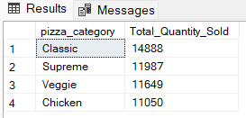

G. Top 5 Pizzas by Revenue

SELECT Top(5) pizza_name, SUM(total_price) AS Total_Revenue

FROM pizza_sales

GROUP BY pizza_name

ORDER BY Total_Revenue DESC

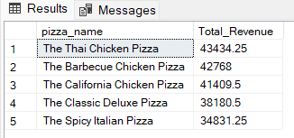

H. Bottom 5 Pizzas by Revenue

SELECT Top 5 pizza_name, SUM(total_price) AS Total_Revenue

FROM pizza_sales

GROUP BY pizza_name

ORDER BY Total_Revenue ASC

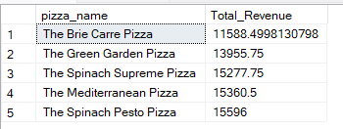

I. Top 5 Pizzas by Quantity

SELECT Top 5 pizza_name, SUM(quantity) AS Total_quantity

FROM pizza_sales

GROUP BY pizza_name

ORDER BY Total_quantity DESC

Output

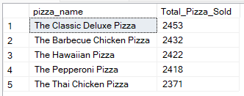

J. Bottom 5 Pizzas by Quantity

SELECT Top 5 pizza_name, SUM(quantity) AS Total_quantity

FROM pizza_sales

GROUP BY pizza_name

ORDER BY Total_quantity asc

Output

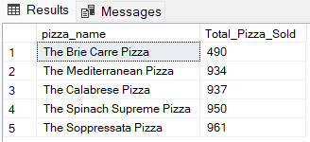

K. Top 5 Pizzas by Total Orders

select top(5) pizza_name, COUNT(DISTINCT(order_id)) as Total_orders from pizza_sales

GROUP BY pizza_name

order by Total_orders desc;

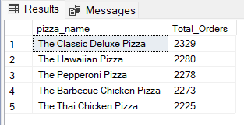

L. Borrom 5 Pizzas by Total Orders

select top(5) pizza_name, COUNT(DISTINCT(order_id)) as Total_orders from pizza_sales

GROUP BY pizza_name

order by Total_orders asc;

